South China University of Technology
《Course》Experiment Report
Experiment Title： Design a campus e-commerce website for SCUT.
Name： MAMATZHANOV ZHUSUP Student ID： 201669998665
Name： FAZLEY MEHRAB SHURJO Student ID： 201669998878
Name：NOPPARUJ TIPPAYAKRAISORN Student ID：201669998576
Class： Database Course 2016(Inter) Group：
Teacher： Yu Zhiwen
Description
【Objective and Requirement】
Objective：
Design a campus e-commerce website for SCUT.

Requirement：
Data information:
- Users’ information includes: Student ID, Name, Sex, College, Major, Dormitory, Password etc.
- Commodities’ information includes: Name, Price, Picture, Description etc.
- Administrators: Account, Name, Sex, Teacher ID, Password etc.
Functions:
- Students can register user accounts, the account is their student ID.
- Users can sell their commodities on the website.
- Users can purchase commodities on the website.
- Users can see their orders and confirm the reception.
- Users can make comments about commodities they have bought.
- Users can delete their commodities.
- Users can modify personal information.
- Administrators can delete all commodities.
- Administrators can view all transaction records.

【Environment】
- Database: SQL Server, Oracle, SQLite etc.
Programming language: python, java, h5, php etc.

Content
【Procedure】
This is project is similar to making online shop. Below pictures show how looks like our website and how does this work. Also we did extra function which are search engine machine and payment with Paypal. To understand more clearly we took we video you can also watch.

The below picture is Home page of website

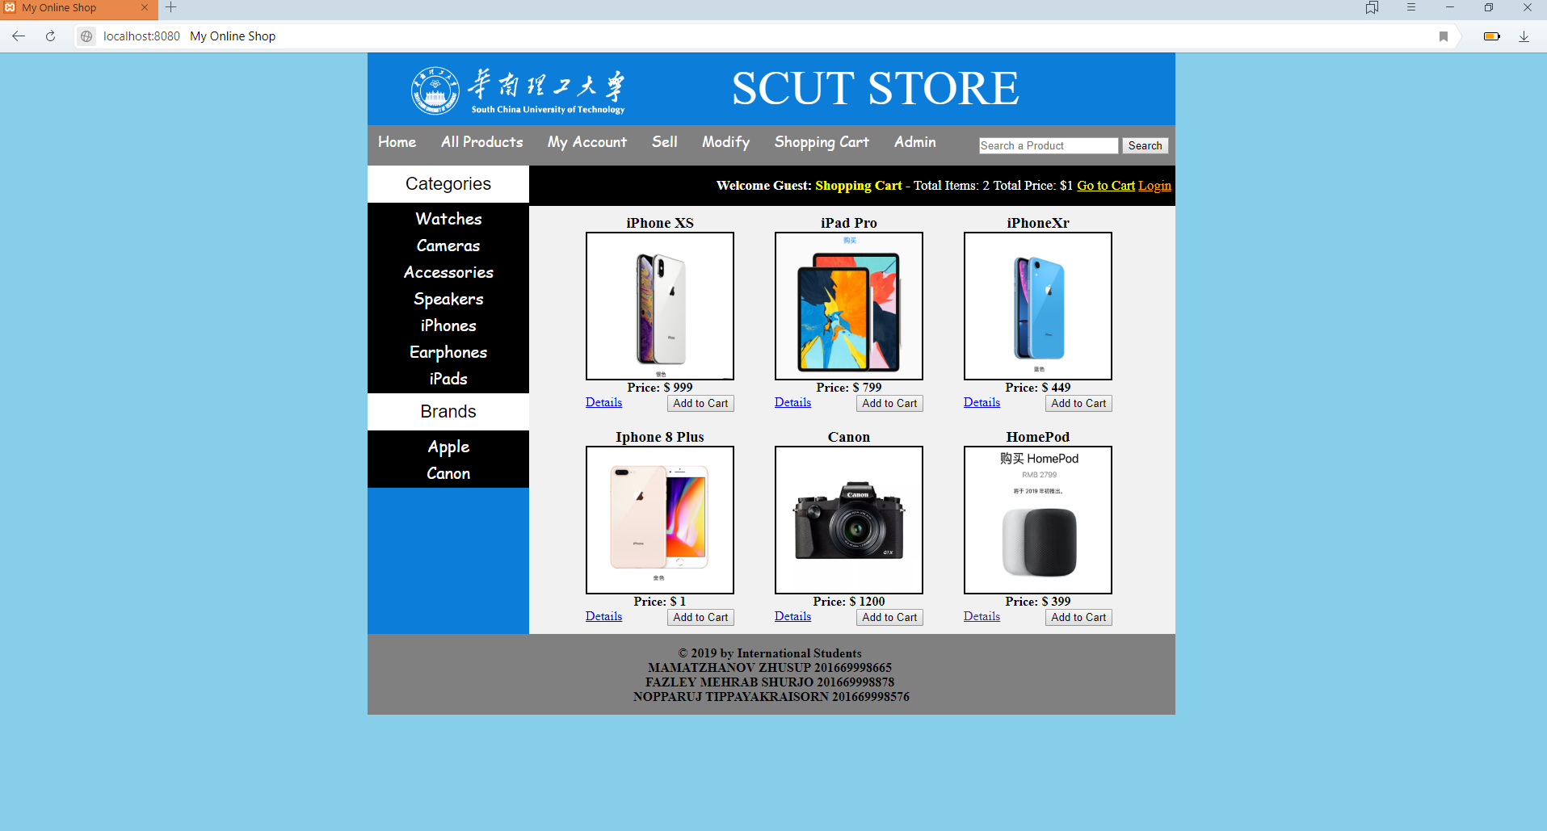
As you can see in picture we run it on localhost

The next picture below is All Product page
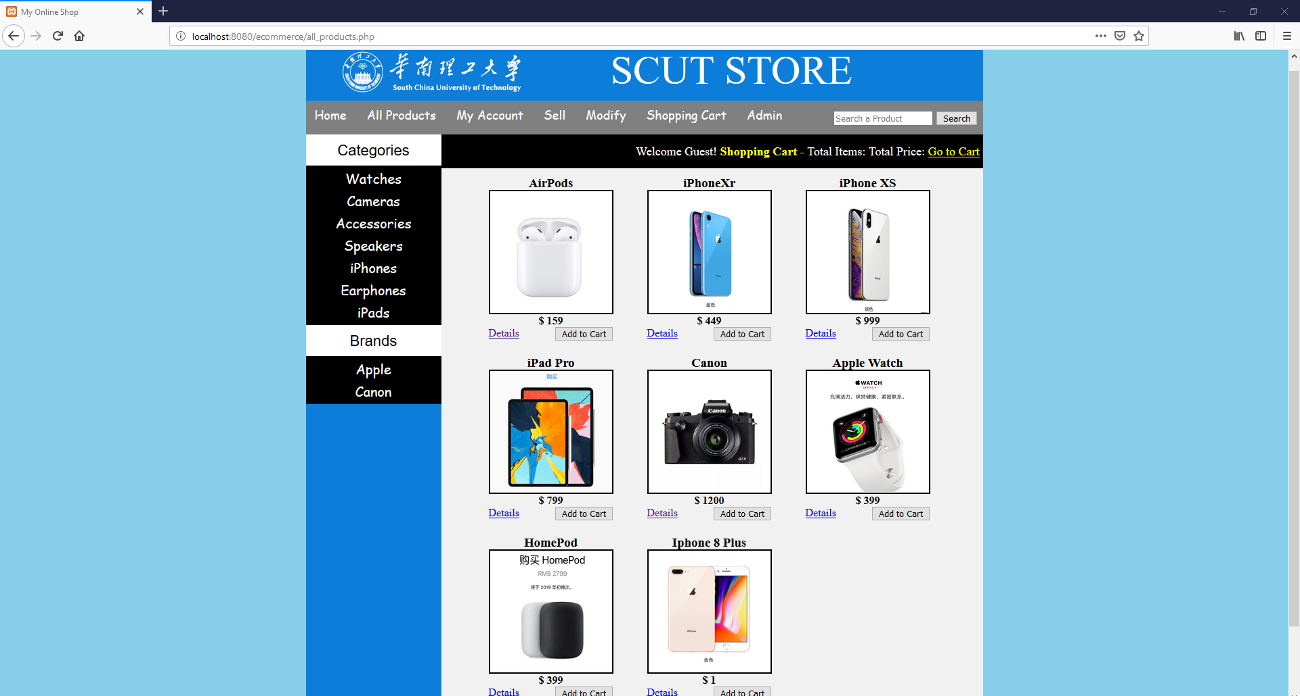

The next picture shows user page
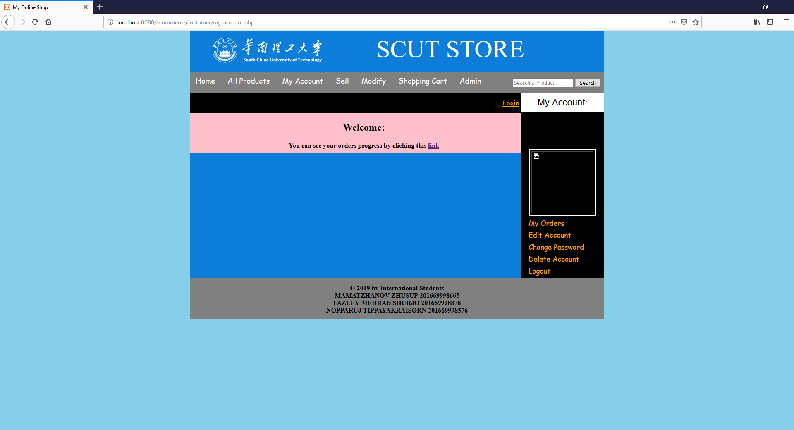
Here you can more links in this page like my orders, Edit account, Changing Account and deleting. All this links work and integrated with database.

The next step showing how to add new commodities.When you click the sell it opens new tab.Here is the pictures

Here is the Login button.
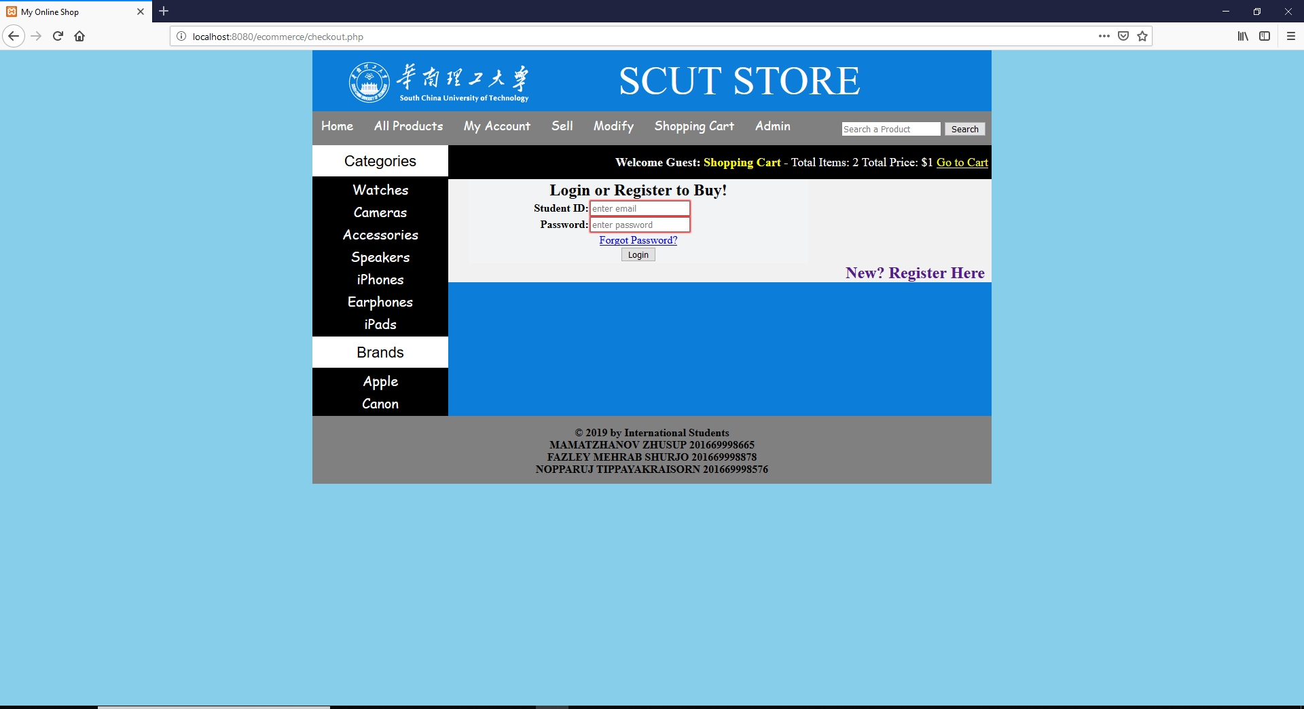

As you can see the picture there is Register button and that button working.

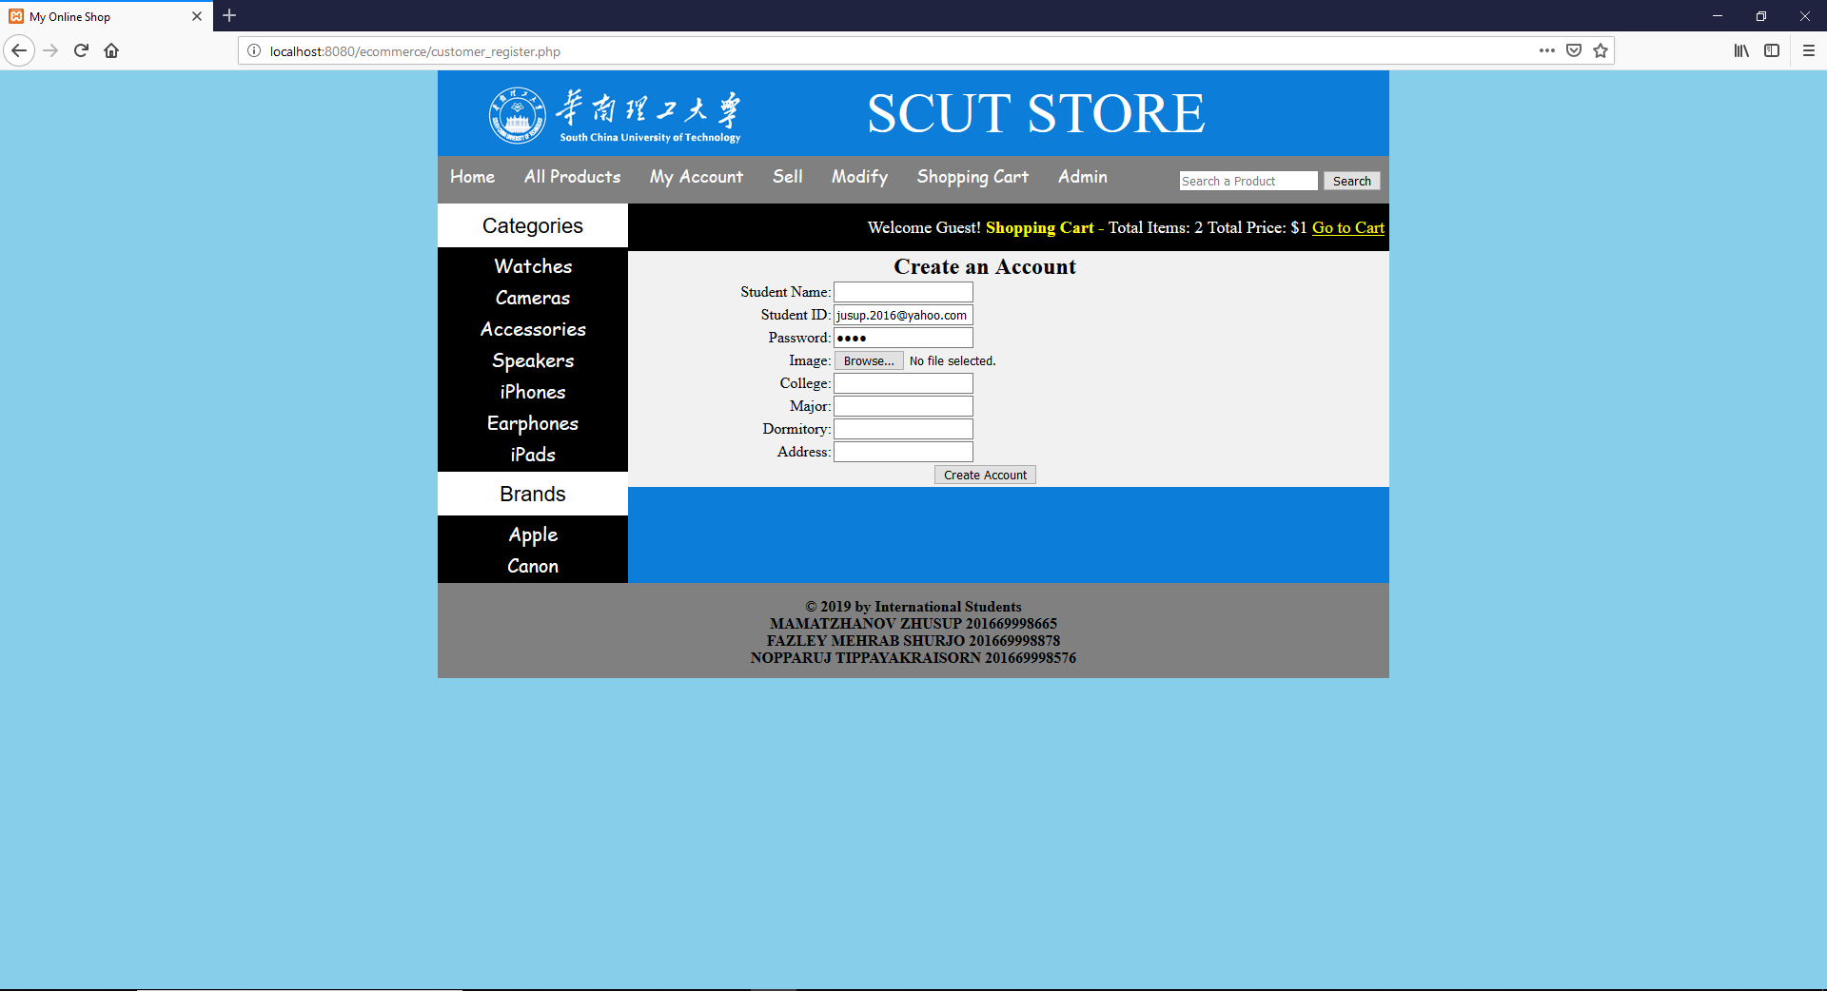

Here in next picture I sign up and open the edit account.
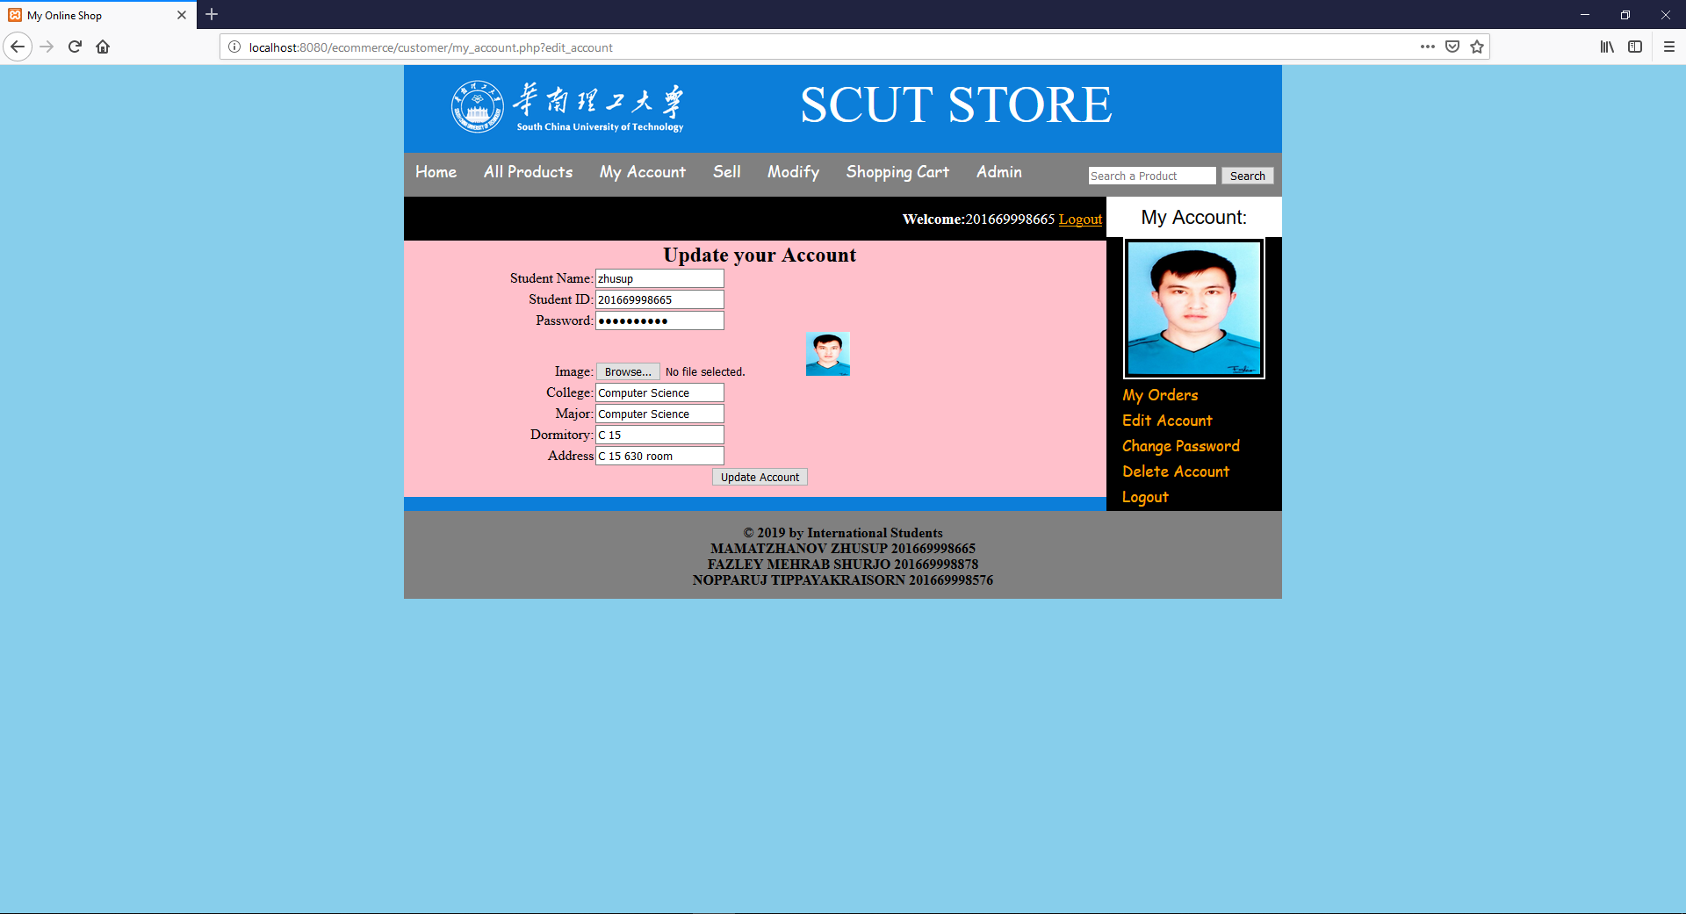
The picture below is Changing password.
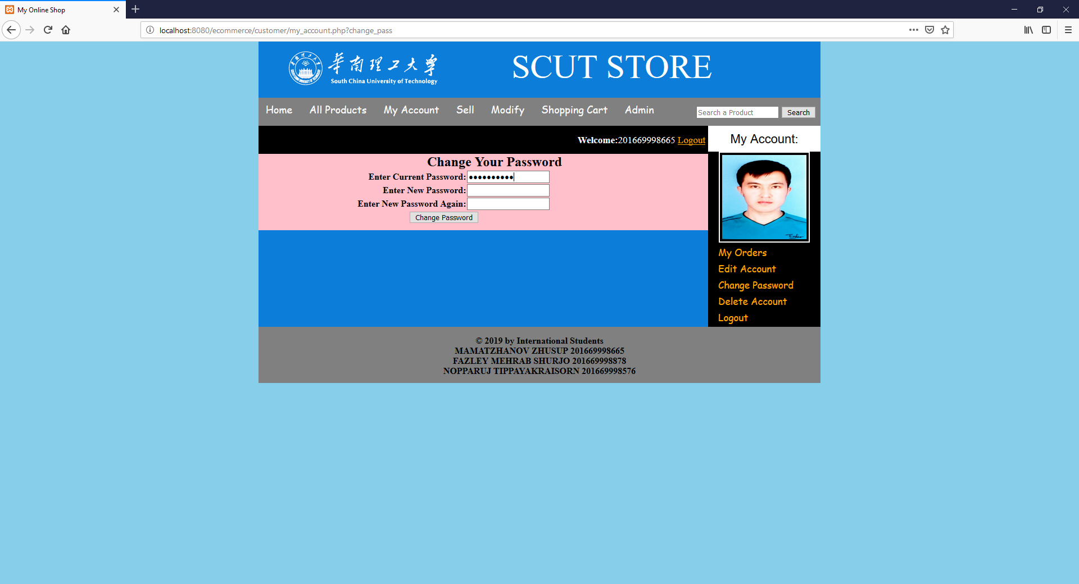
The other two button is also working. Delete account and Logout.
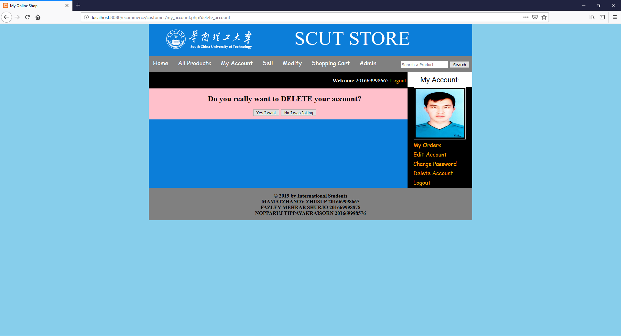
The next step is selling item. Here when you click the sell button its open new tab.
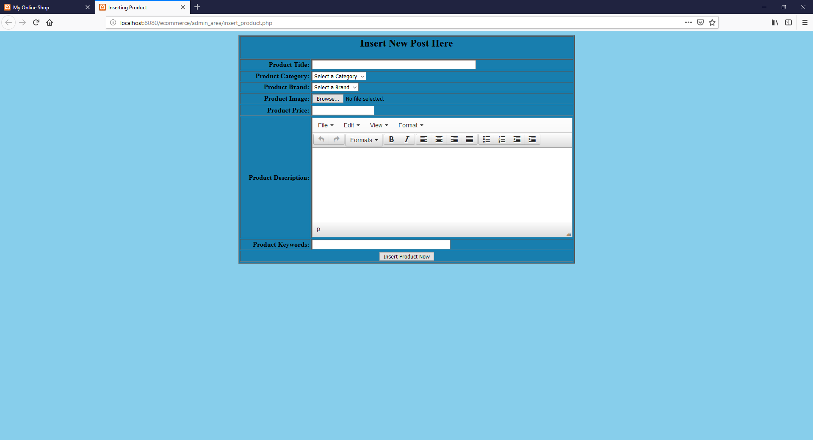
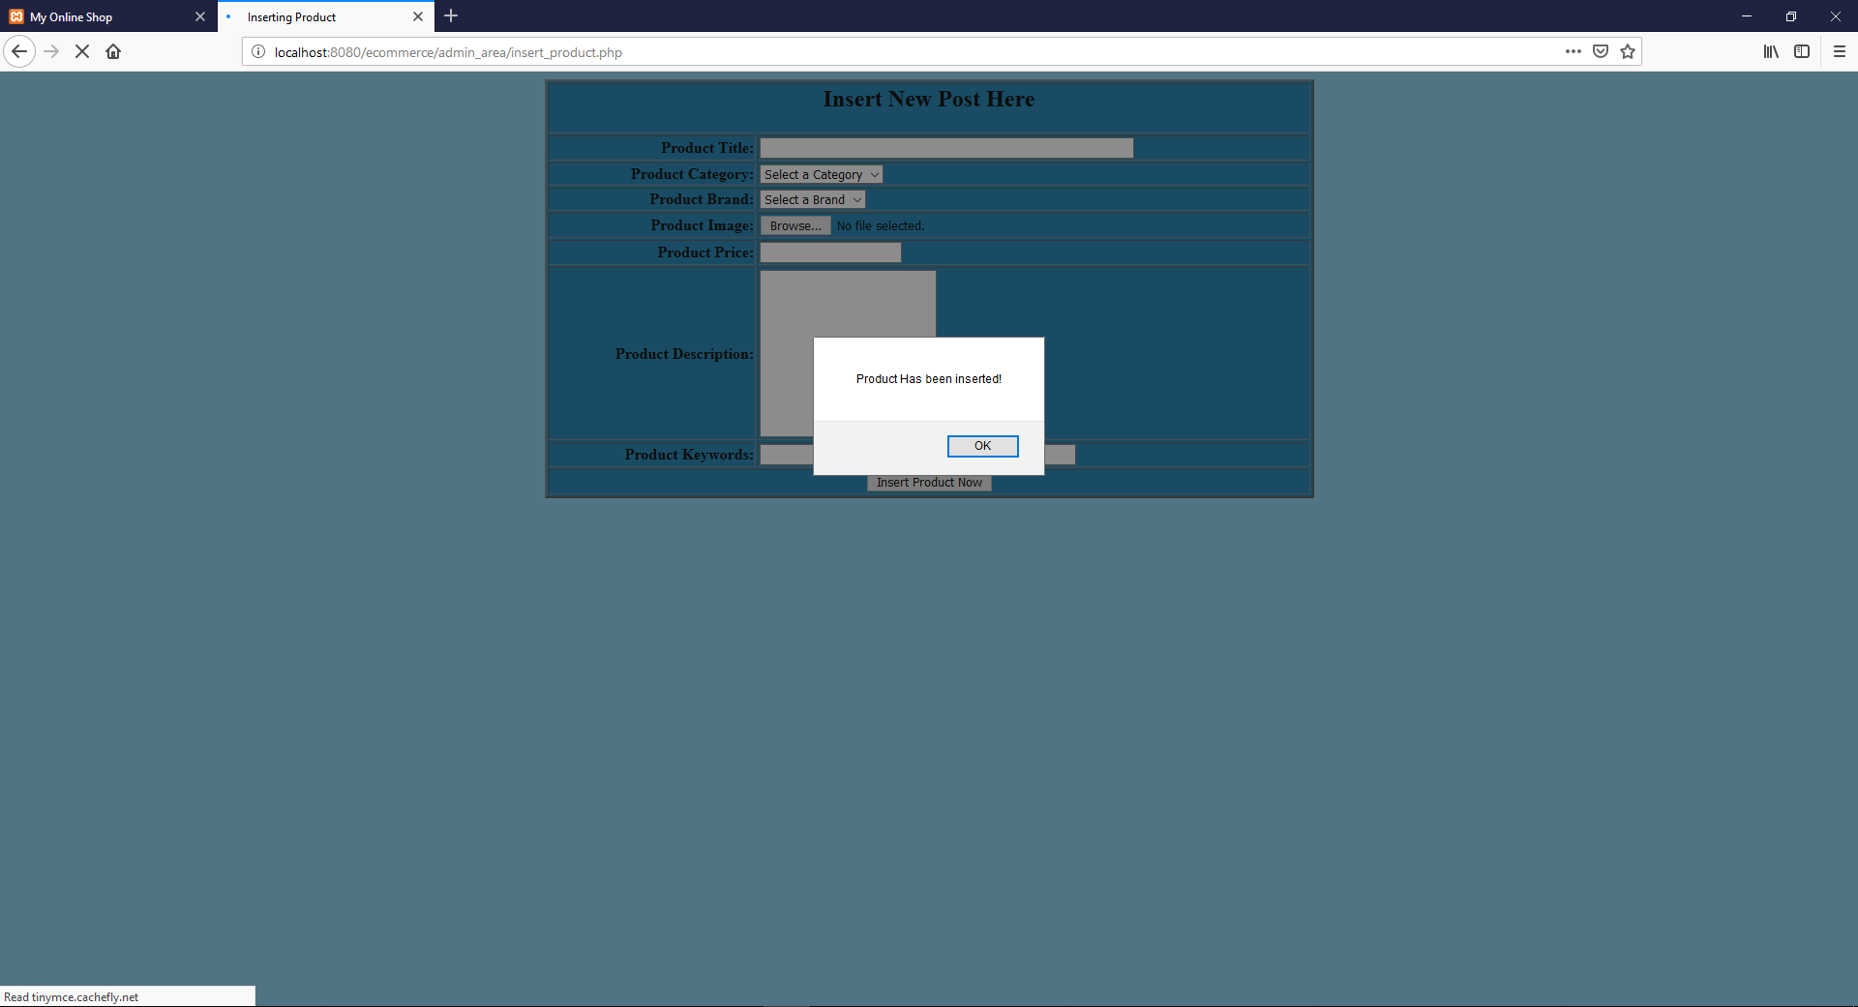

The next page is Modify page where you can edit the price and everything related to that item.When click that modify button its open new tab.
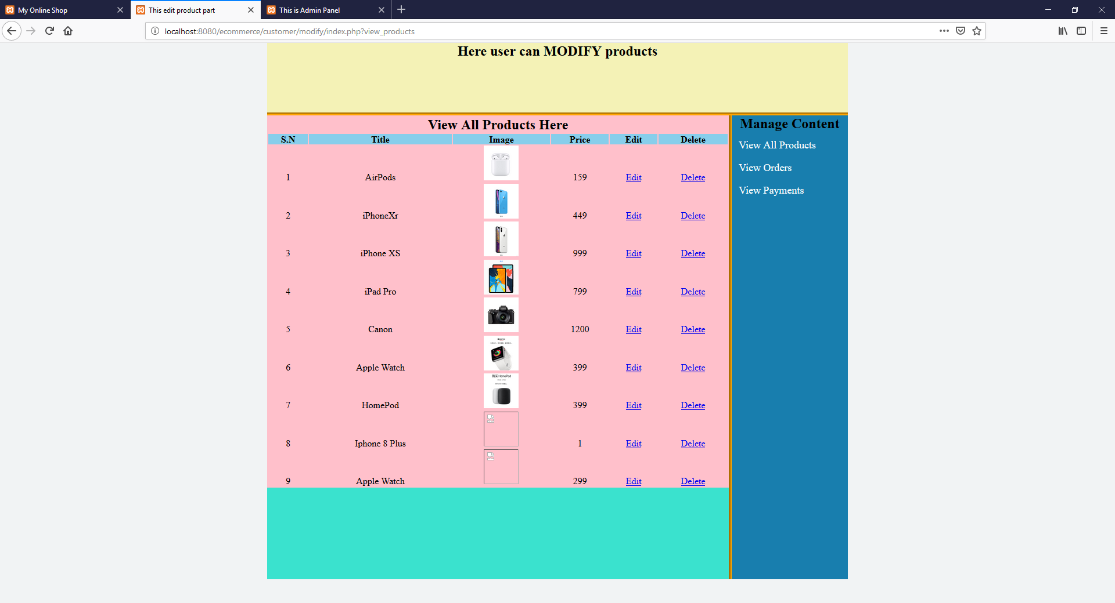
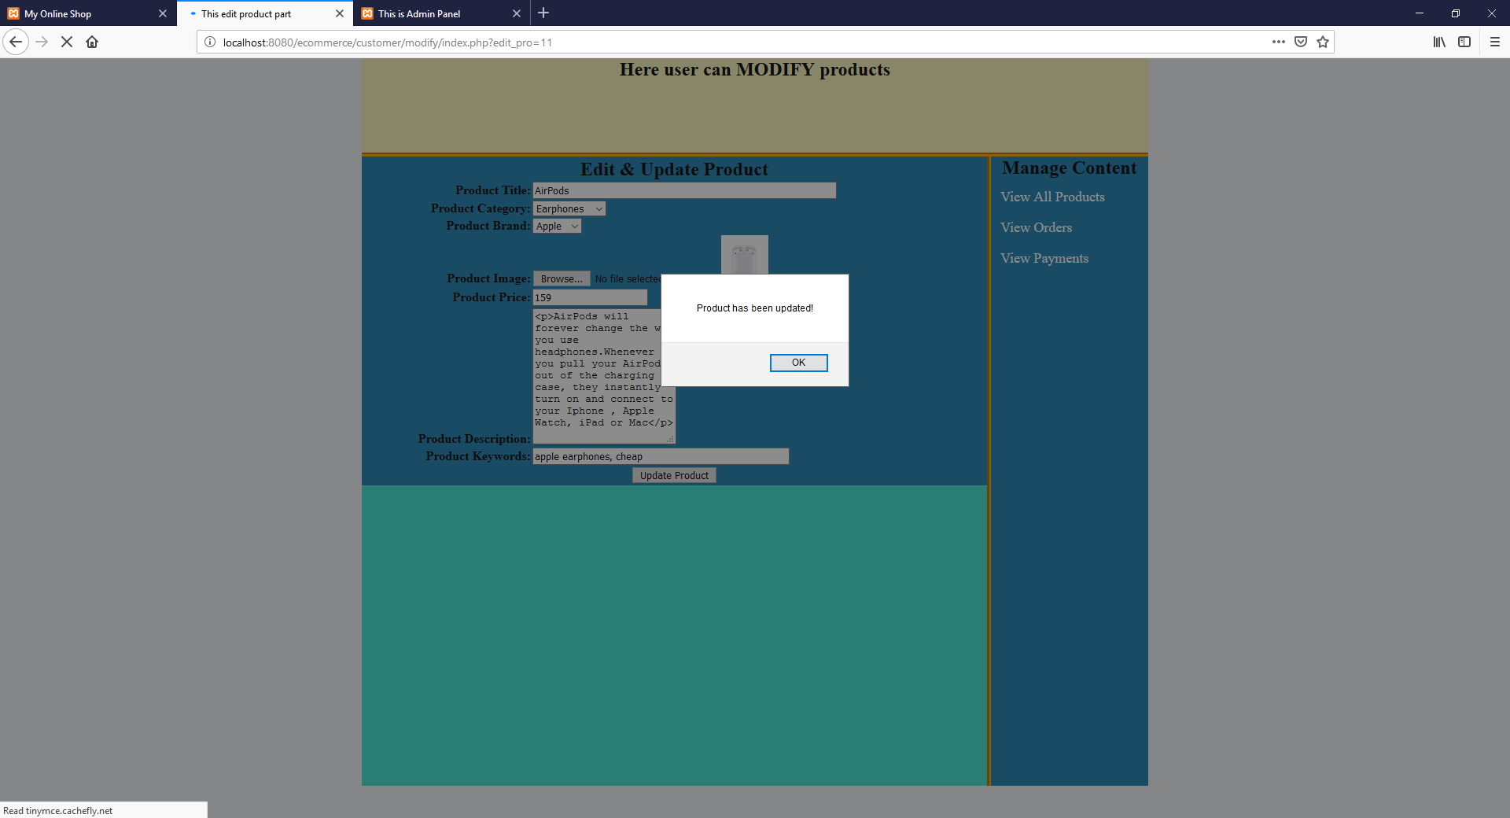

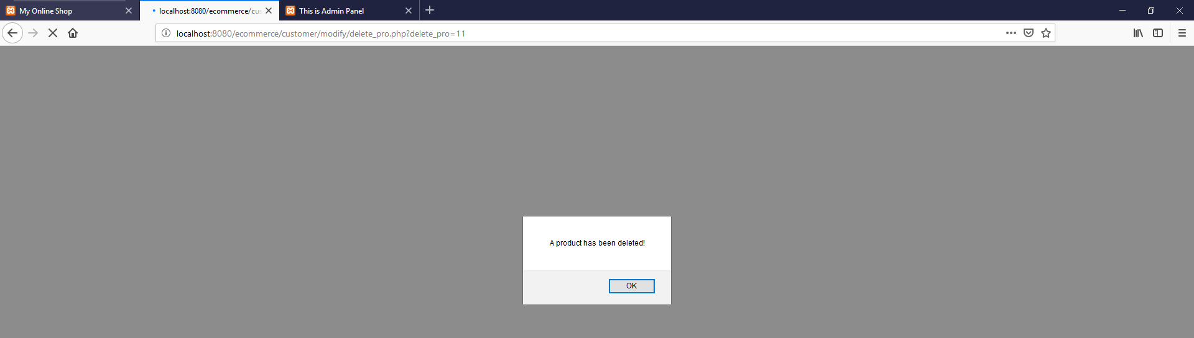

And in the same page we can see the orders and payment.
The next picture is the shopping cart.
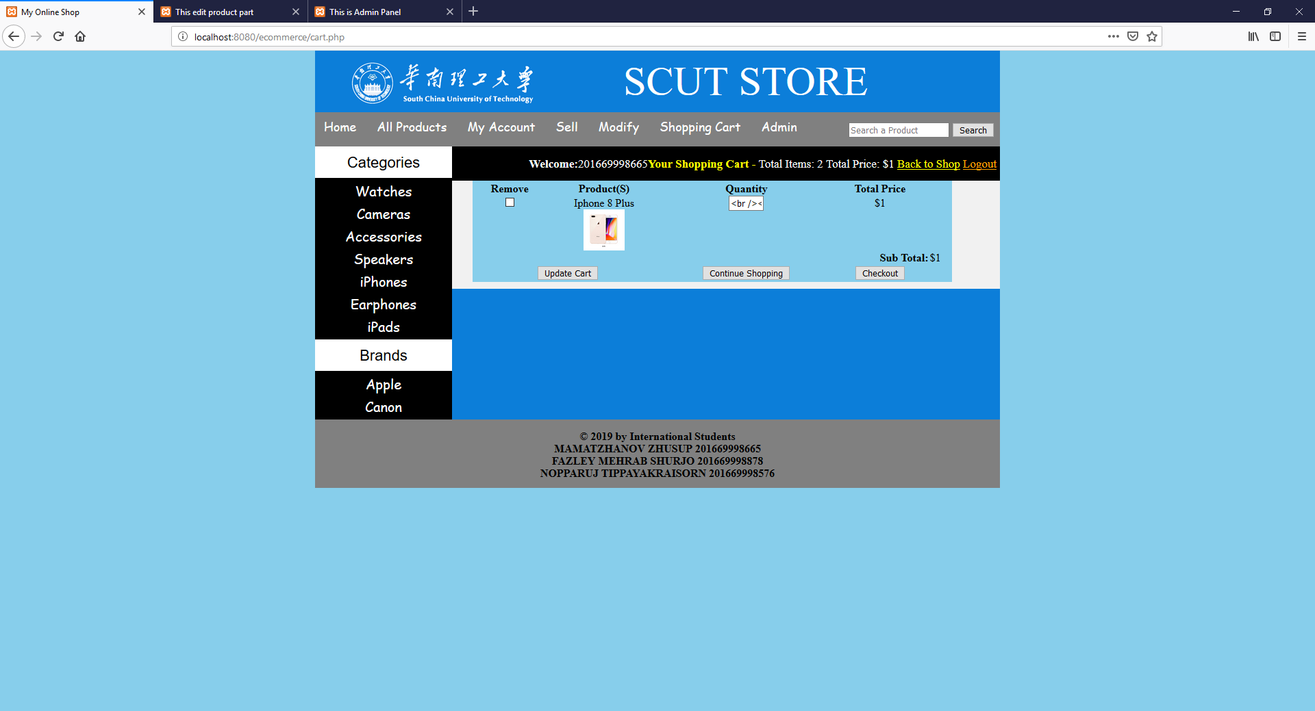
In this page every buttons work you can see the video.

And the next page is Admin part. When we click this button its open the admin login portal.
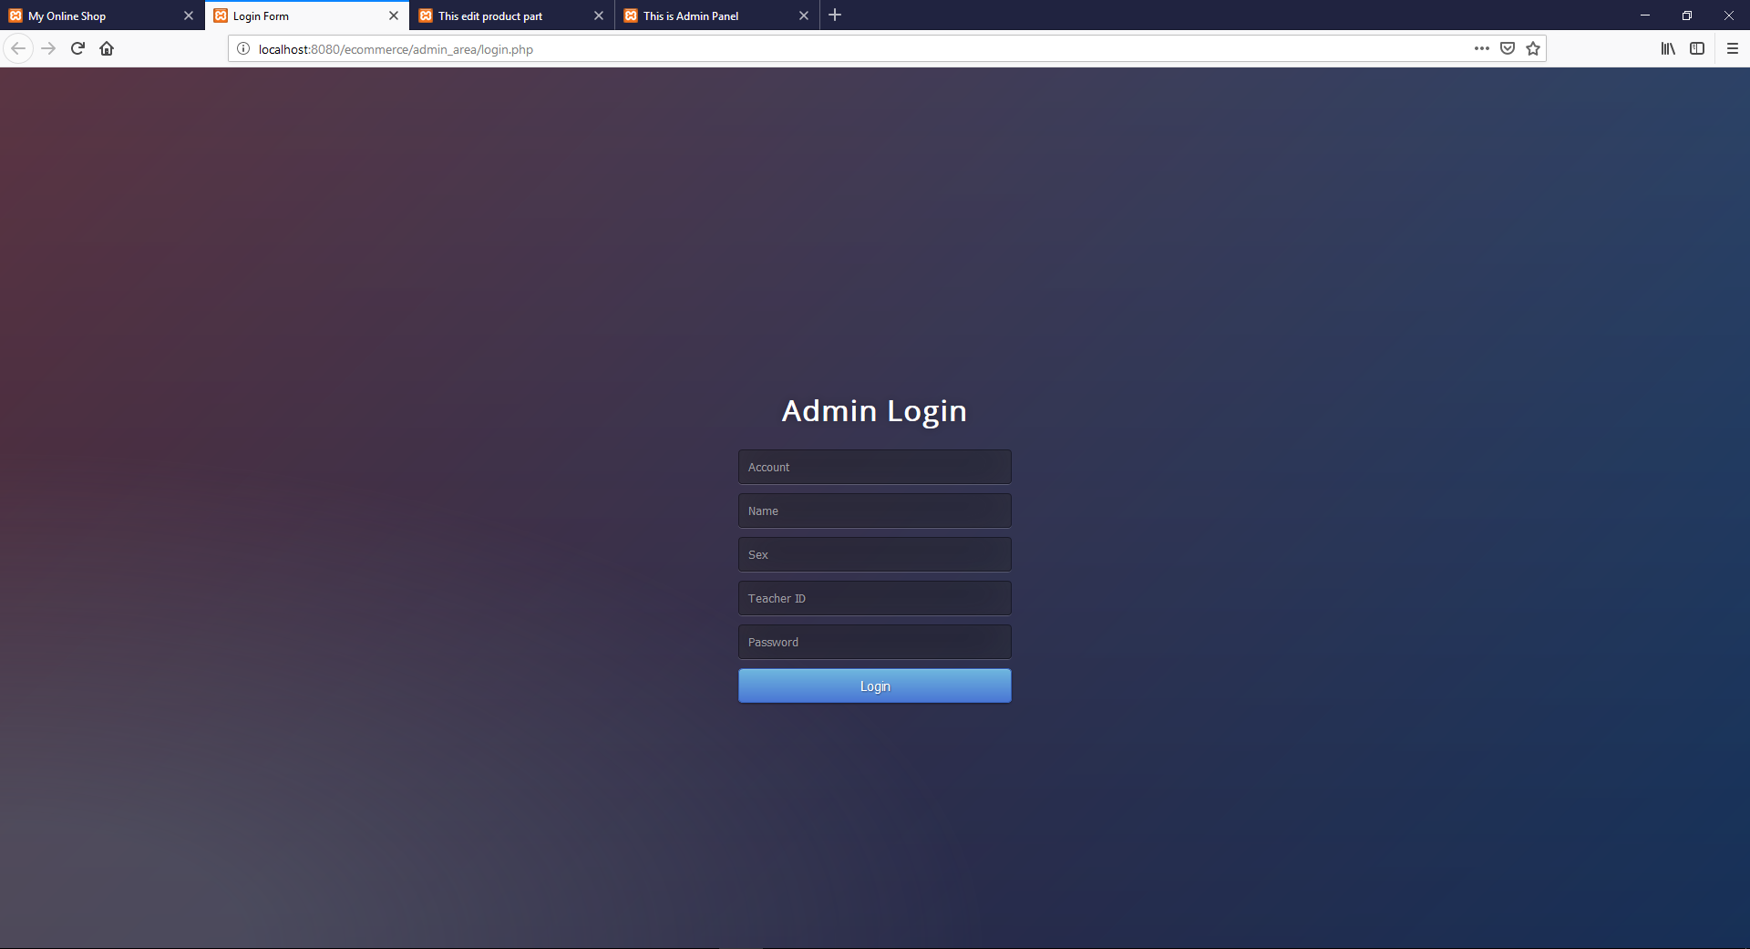
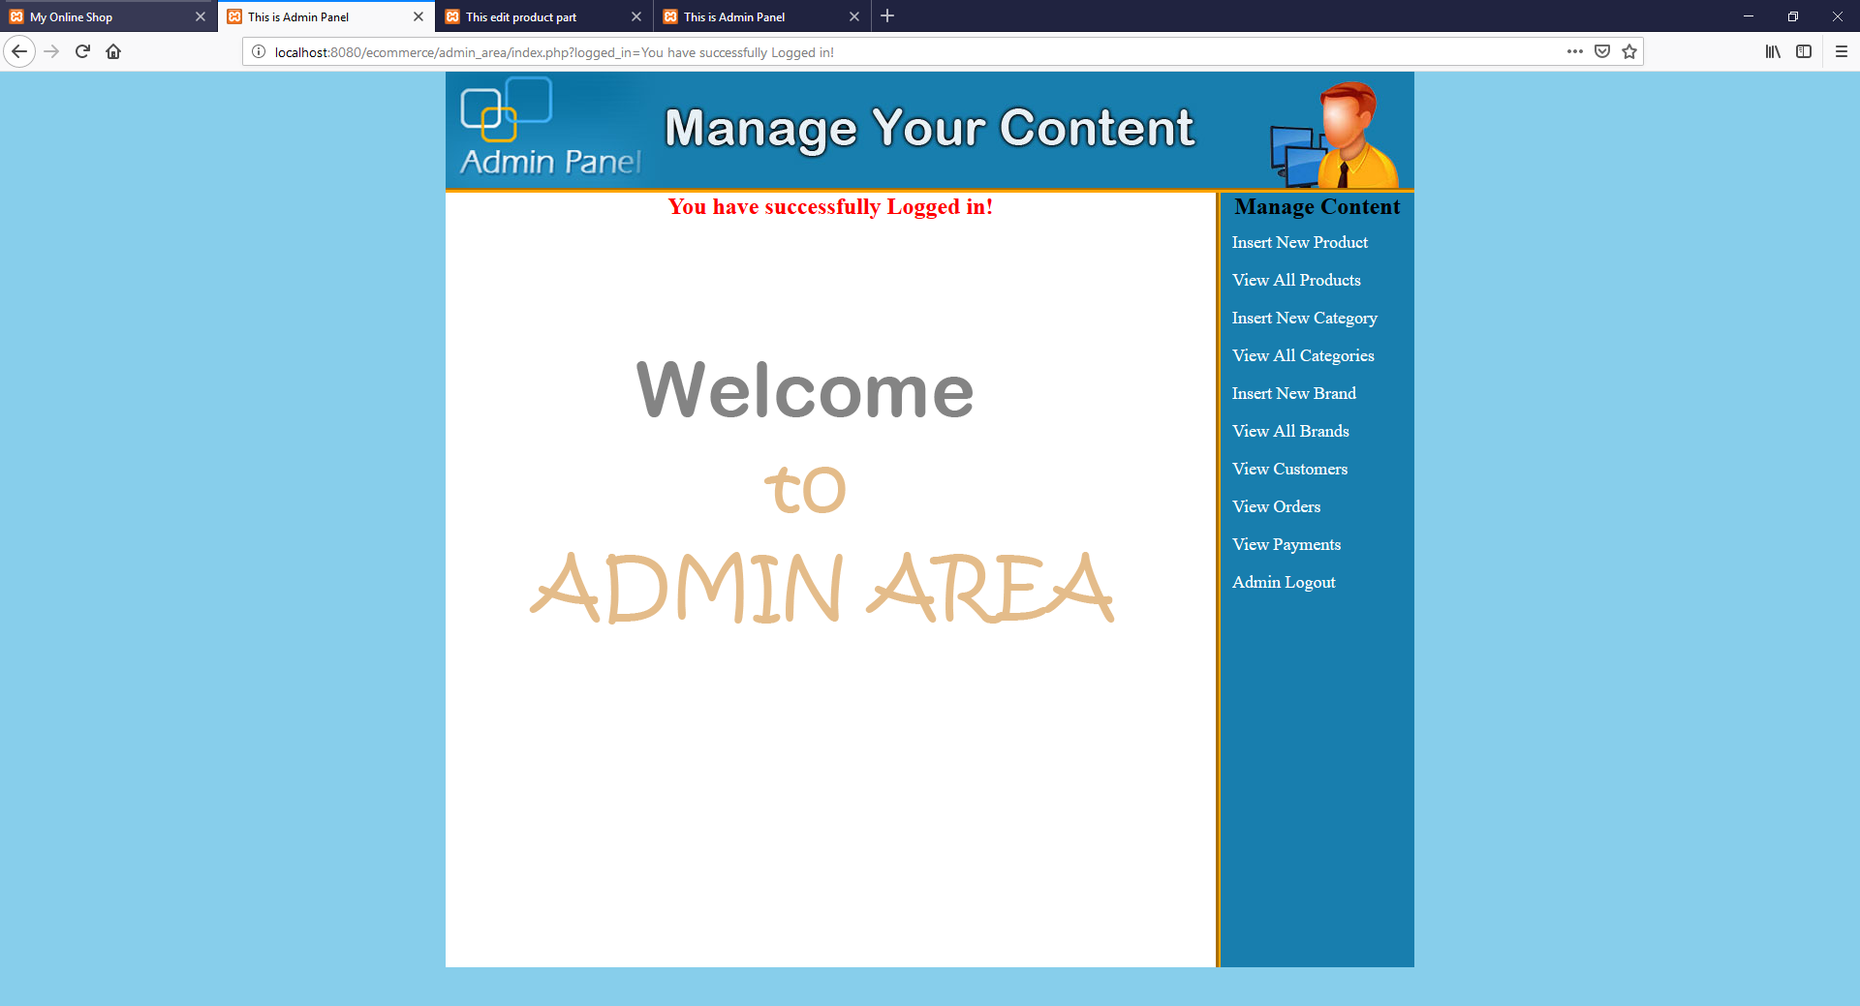
Here in Insert button we can add new items to the website.
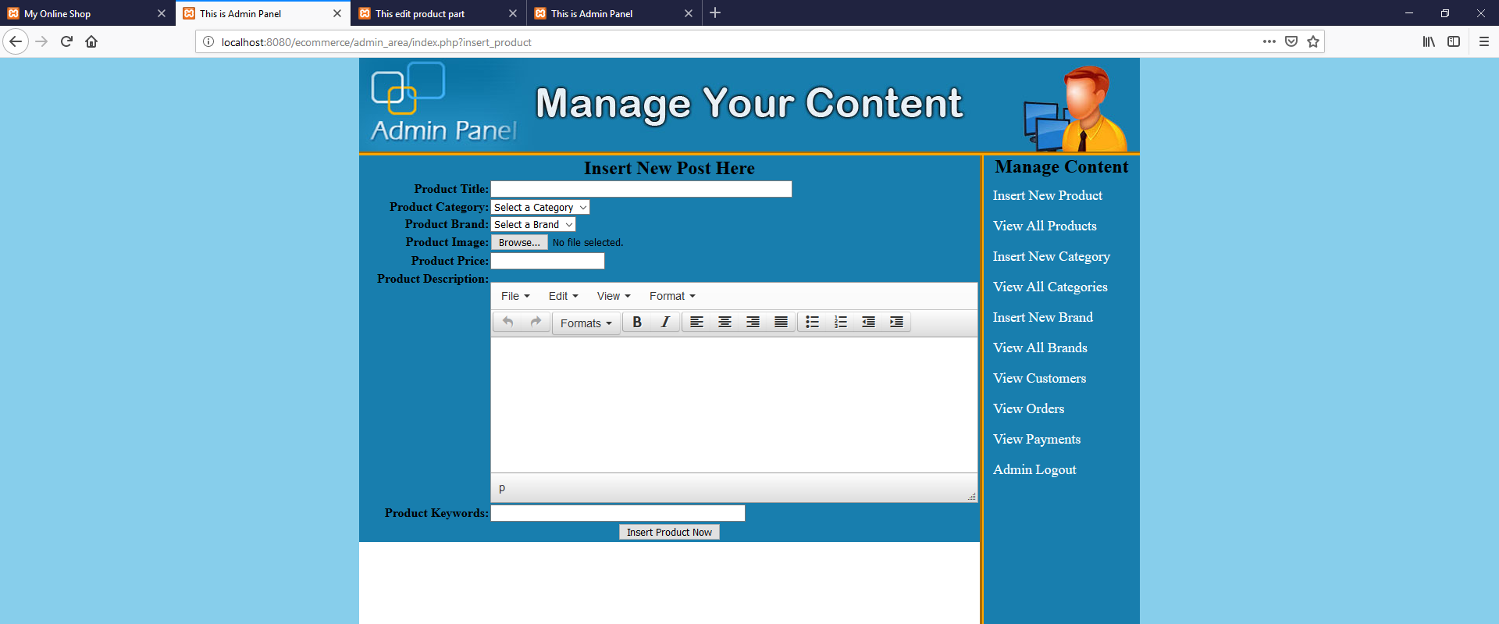
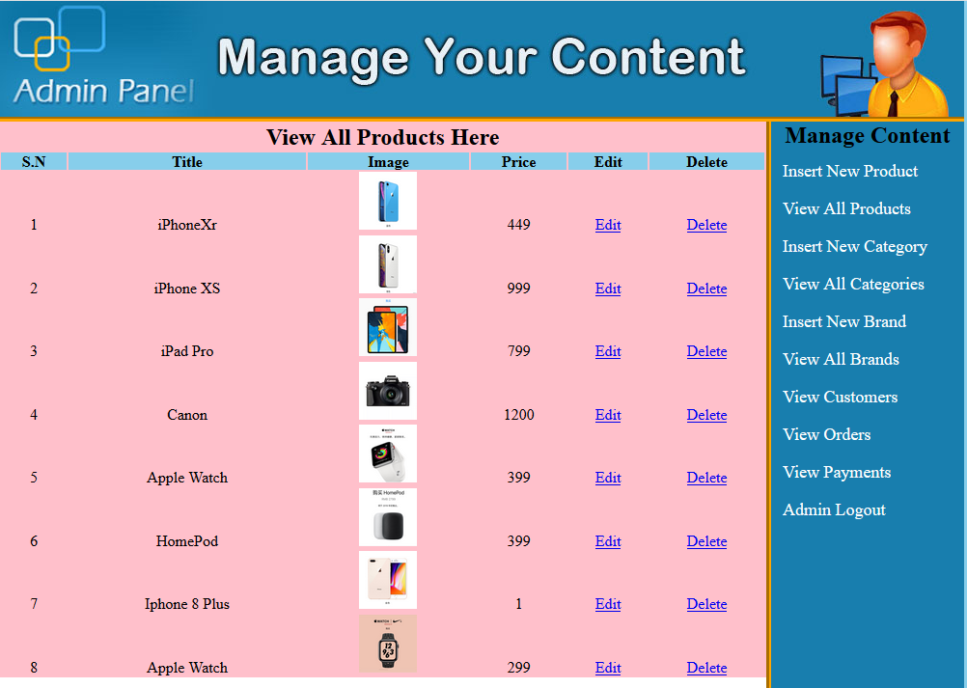
In the next pages we can add categories and edit categories.
Also we can see the customers.
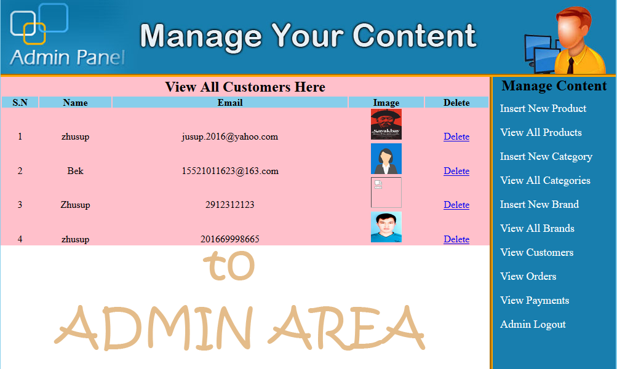
And the other step we can see orders and payment and Admin log out.
All this buttons works. You can see all of them in video.

DATABASE CODE
-- phpMyAdmin SQL Dump
-- version 4.8.4
-- https://www.phpmyadmin.net/
--
-- Host: 127.0.0.1
-- Generation Time: Jan 13, 2019 at 02:18 AM
-- Server version: 10.1.37-MariaDB
-- PHP Version: 5.6.39

SET SQL_MODE = "NO_AUTO_VALUE_ON_ZERO";
SET AUTOCOMMIT = 0;
START TRANSACTION;
SET time_zone = "+00:00";

/*!40101 SET @OLD_CHARACTER_SET_CLIENT=@@CHARACTER_SET_CLIENT */;
/*!40101 SET @OLD_CHARACTER_SET_RESULTS=@@CHARACTER_SET_RESULTS */;
/*!40101 SET @OLD_COLLATION_CONNECTION=@@COLLATION_CONNECTION */;
/*!40101 SET NAMES utf8mb4 */;

--
-- Database: `ecommerce`
--

-- --------------------------------------------------------

--
-- Table structure for table `admins`
--

CREATE TABLE `admins` (
`user_id` int(10) NOT NULL,
`user_email` varchar(255) NOT NULL,
`user_pass` varchar(255) NOT NULL
) ENGINE=InnoDB DEFAULT CHARSET=latin1;

--
-- Dumping data for table `admins`
--

INSERT INTO `admins` (`user_id`, `user_email`, `user_pass`) VALUES
(1, 'jusup.2016@yahoo.com', '1234'),
(2, 'saima@yahoo.com', 'khan');

-- --------------------------------------------------------

--
-- Table structure for table `brands`
--

CREATE TABLE `brands` (
`brand_id` int(100) NOT NULL,
`brand_title` text NOT NULL
) ENGINE=InnoDB DEFAULT CHARSET=latin1;

--
-- Dumping data for table `brands`
--

INSERT INTO `brands` (`brand_id`, `brand_title`) VALUES
(5, 'Apple'),
(6, 'Canon');

-- --------------------------------------------------------

--
-- Table structure for table `cart`
--

CREATE TABLE `cart` (
`p_id` int(10) NOT NULL,
`ip_add` varchar(255) NOT NULL,
`qty` int(10) NOT NULL
) ENGINE=InnoDB DEFAULT CHARSET=latin1;

--
-- Dumping data for table `cart`
--

INSERT INTO `cart` (`p_id`, `ip_add`, `qty`) VALUES
(6, '::1', 0),
(18, '::1', 0);

-- --------------------------------------------------------

--
-- Table structure for table `categories`
--

CREATE TABLE `categories` (
`cat_id` int(100) NOT NULL,
`cat_title` text NOT NULL
) ENGINE=InnoDB DEFAULT CHARSET=latin1;

--
-- Dumping data for table `categories`
--

INSERT INTO `categories` (`cat_id`, `cat_title`) VALUES
(1, 'Watches'),
(2, 'Cameras'),
(3, 'Accessories'),
(4, 'Speakers'),
(6, 'iPhones'),
(7, 'Earphones'),
(8, 'iPads');

-- --------------------------------------------------------

--
-- Table structure for table `customers`
--

CREATE TABLE `customers` (
`customer_id` int(10) NOT NULL,
`customer_ip` varchar(255) NOT NULL,
`customer_name` text NOT NULL,
`customer_email` varchar(100) NOT NULL,
`customer_pass` varchar(100) NOT NULL,
`customer_country` text NOT NULL,
`customer_city` text NOT NULL,
`customer_contact` varchar(255) NOT NULL,
`customer_address` text NOT NULL,
`customer_image` text NOT NULL
) ENGINE=InnoDB DEFAULT CHARSET=latin1;

--
-- Dumping data for table `customers`
--

INSERT INTO `customers` (`customer_id`, `customer_ip`, `customer_name`, `customer_email`, `customer_pass`, `customer_country`, `customer_city`, `customer_contact`, `customer_address`, `customer_image`) VALUES
(7, '::1', 'zhusup', 'jusup.2016@yahoo.com', 'jaktel2016', 'United States', 'Guangzhou', 'Daxuecheng ', 'Xingangdong Road', 'sayakbai.jpg'),
(8, '::1', 'Bek', '15521011623@163.com', 'jaktel2016', 'Computer Science', 'Computer Science 2016', 'C 15', 'C 15 702 room', 'img_avatar2.png'),
(9, '::1', 'Zhusup', '2912312123', '12345', 'BBA', 'International Trade', 'C14', 'C14 403', ''),
(10, '::1', 'zhusup', '201669998665', 'jaktel2016', 'Computer Science', 'Computer Science', 'C 15', 'C 15 630 room', 'photo.jpg');

-- --------------------------------------------------------

--
-- Table structure for table `orders`
--

CREATE TABLE `orders` (
`order_id` int(100) NOT NULL,
`p_id` int(100) NOT NULL,
`c_id` int(100) NOT NULL,
`qty` int(100) NOT NULL,
`invoice_no` int(100) NOT NULL,
`status` text NOT NULL,
`order_date` date NOT NULL
) ENGINE=MyISAM DEFAULT CHARSET=latin1;

--
-- Dumping data for table `orders`
--

INSERT INTO `orders` (`order_id`, `p_id`, `c_id`, `qty`, `invoice_no`, `status`, `order_date`) VALUES
(5, 8, 5, 1, 462643381, 'Completed', '0000-00-00'),

-- --------------------------------------------------------

--
-- Table structure for table `payments`
--

CREATE TABLE `payments` (
`payment_id` int(100) NOT NULL,
`amount` int(100) NOT NULL,
`customer_id` int(100) NOT NULL,
`product_id` int(100) NOT NULL,
`trx_id` varchar(255) NOT NULL,
`currency` text NOT NULL,
`payment_date` date NOT NULL
) ENGINE=MyISAM DEFAULT CHARSET=latin1;

--
-- Dumping data for table `payments`
--

INSERT INTO `payments` (`payment_id`, `amount`, `customer_id`, `product_id`, `trx_id`, `currency`, `payment_date`) VALUES
(1, 800, 5, 6, '31B07494JS505133P', 'USD', '0000-00-00'),
(2, 500, 5, 9, '18747053K31546734', 'USD', '0000-00-00'),
(3, 1000, 5, 9, '183154524M7953521', 'USD', '0000-00-00'),

-- --------------------------------------------------------

--
-- Table structure for table `products`
--

CREATE TABLE `products` (
`product_id` int(100) NOT NULL,
`product_cat` int(100) NOT NULL,
`product_brand` int(100) NOT NULL,
`product_title` varchar(255) NOT NULL,
`product_price` int(100) NOT NULL,
`product_desc` text NOT NULL,
`product_image` text NOT NULL,
`product_keywords` text NOT NULL
) ENGINE=InnoDB DEFAULT CHARSET=latin1;

--
-- Dumping data for table `products`
--

INSERT INTO `products` (`product_id`, `product_cat`, `product_brand`, `product_title`, `product_price`, `product_desc`, `product_image`, `product_keywords`) VALUES
(12, 6, 5, 'iPhoneXr', 449, '<p>For a limited time, get iPhone XR from $449 or XS from $ 699$ when you trade in your iPhones</p>', 'IMG_8065.JPG', 'iphone xr, cheap'),
(13, 6, 5, 'iPhone XS', 999, '<p>Super Retina HD display</p>', 'IMG_8066.JPG', 'iphone xs'),
(14, 8, 5, 'iPad Pro', 799, '<p>Our most advanced technology in the thinnest iPad ever</p>', 'IMG_8069.JPG', 'iPad'),
(15, 2, 6, 'Canon', 1200, '<p>The professional camera</p>', 'IMG_8061.JPG', 'camera'),
(16, 1, 5, 'Apple Watch', 399, '<p>Silver Aluminum Case with White Sport Band</p>', 'IMG_8074.JPG', 'apple watch'),
(17, 4, 5, 'HomePod', 399, '<p>HomePod speaker</p>', 'IMG_8075.JPG', 'speaker'),
(18, 6, 5, 'Iphone 8 Plus', 1, '<p>Iphone 8 , 128GB</p>', 'IMG_8067.JPG', 'iphone 8'),
(19, 1, 5, 'Apple Watch', 299, '<p>New Design of apple watches</p>', 'IMG_8073.JPG', 'apple watch');

--
-- Indexes for dumped tables
--

--
-- Indexes for table `admins`
--
ALTER TABLE `admins`
ADD PRIMARY KEY (`user_id`);

--
-- Indexes for table `brands`
--
ALTER TABLE `brands`
ADD PRIMARY KEY (`brand_id`);

--
-- Indexes for table `cart`
--
ALTER TABLE `cart`
ADD PRIMARY KEY (`p_id`);

--
-- Indexes for table `categories`
--
ALTER TABLE `categories`
ADD PRIMARY KEY (`cat_id`);

--
-- Indexes for table `customers`
--
ALTER TABLE `customers`
ADD PRIMARY KEY (`customer_id`);

--
-- Indexes for table `orders`
--
ALTER TABLE `orders`
ADD PRIMARY KEY (`order_id`);

--
-- Indexes for table `payments`
--
ALTER TABLE `payments`
ADD PRIMARY KEY (`payment_id`);

--
-- Indexes for table `products`
--
ALTER TABLE `products`
ADD PRIMARY KEY (`product_id`);

--
-- AUTO_INCREMENT for dumped tables
--

--
-- AUTO_INCREMENT for table `admins`
--
ALTER TABLE `admins`
MODIFY `user_id` int(10) NOT NULL AUTO_INCREMENT, AUTO_INCREMENT=3;

--
-- AUTO_INCREMENT for table `brands`
--
ALTER TABLE `brands`
MODIFY `brand_id` int(100) NOT NULL AUTO_INCREMENT, AUTO_INCREMENT=7;

--
-- AUTO_INCREMENT for table `categories`
--
ALTER TABLE `categories`
MODIFY `cat_id` int(100) NOT NULL AUTO_INCREMENT, AUTO_INCREMENT=9;

--
-- AUTO_INCREMENT for table `customers`
--
ALTER TABLE `customers`
MODIFY `customer_id` int(10) NOT NULL AUTO_INCREMENT, AUTO_INCREMENT=11;

--
-- AUTO_INCREMENT for table `orders`
--
ALTER TABLE `orders`
MODIFY `order_id` int(100) NOT NULL AUTO_INCREMENT, AUTO_INCREMENT=13;

--
-- AUTO_INCREMENT for table `payments`
--
ALTER TABLE `payments`
MODIFY `payment_id` int(100) NOT NULL AUTO_INCREMENT, AUTO_INCREMENT=13;

--
-- AUTO_INCREMENT for table `products`
--
ALTER TABLE `products`
MODIFY `product_id` int(100) NOT NULL AUTO_INCREMENT, AUTO_INCREMENT=20;
COMMIT;

/*!40101 SET CHARACTER_SET_CLIENT=@OLD_CHARACTER_SET_CLIENT */;
/*!40101 SET CHARACTER_SET_RESULTS=@OLD_CHARACTER_SET_RESULTS */;
/*!40101 SET COLLATION_CONNECTION=@OLD_COLLATION_CONNECTION */;

Conclusion
We think the tests we did went smoothly and I had no problems.This was good experience for us. An interesting future we going to develop this website.

Teacher’s Comments and Score
Comment：

Score： Signature：
Date：2019.01.13

